**Hand Book**

**Deep Learning**

**Disclaimer: The content is curated from online/offline resources and used for educational purpose only**

**Table of Contents**

Learning Outcomes iii

Chapter 5: Introduction to Deep Learning 4

5.1 Introduction to Deep Learning for Sustainability 4

5.2 Neurons and Layers 8

References: 24

# Premium Vector | White abstract background in 3d paper style | Abstract backgrounds, Abstract, Geometric backgroundLearning Outcomes

After completing this handbook, learner will be able to

* Identify and describe the roles of neurons as the basic units of a neural network.
* Differentiate between input, hidden, and output layers and explain their purposes in a neural network.
* Define activation functions and explain their importance in introducing non-linearity to neural networks.
* Compare and contrast commonly used activation functions, such as ReLU, Sigmoid, and Tanh, and describe scenarios where each is most applicable.
* Explain the concept of a loss function and its role in assessing the performance of a neural network.
* Illustrate how specific loss functions like Mean Squared Error and Cross-Entropy are calculated and applied in different machine learning contexts.
* Define optimization algorithms and their importance in updating neural network weights to minimize loss.
* Explain the mechanisms of common optimization methods, including Gradient Descent and Adam, and their advantages in training neural networks.
* Synthesize knowledge of neurons, activation functions, loss functions, and optimization algorithms to outline the workflow of designing and training a basic neural network.
* Evaluate the impact of various choices (e.g., activation functions, loss functions, optimization methods) on network performance.

Chapter 5: Introduction to Deep Learning

|  |
| --- |
| **Learning Outcomes:**  By the end of this chapter, learners will be able to:   1. Identify and describe the roles of neurons as the basic units of a neural network. 2. Differentiate between input, hidden, and output layers and explain their purposes in a neural network. 3. Define activation functions and explain their importance in introducing non-linearity to neural networks. 4. Compare and contrast commonly used activation functions, such as ReLU, Sigmoid, and Tanh, and describe scenarios where each is most applicable. 5. Explain the concept of a loss function and its role in assessing the performance of a neural network. 6. Illustrate how specific loss functions like Mean Squared Error and Cross-Entropy are calculated and applied in different machine learning contexts. 7. Define optimization algorithms and their importance in updating neural network weights to minimize loss. 8. Explain the mechanisms of common optimization methods, including Gradient Descent and Adam, and their advantages in training neural networks. 9. Synthesize knowledge of neurons, activation functions, loss functions, and optimization algorithms to outline the workflow of designing and training a basic neural network. 10. Evaluate the impact of various choices (e.g., activation functions, loss functions, optimization methods) on network performance. |

# 5.1 Introduction to Deep Learning for Sustainability

DL models are particularly effective in tasks like image recognition, natural language processing, and predictive analytics.

In the context of sustainability, DL excels at processing diverse environmental datasets, such as satellite imagery, weather patterns, and sensor data, to extract actionable insights. This capability positions it as a transformative technology for creating solutions that promote a balance between development and environmental preservation.

Deep Learning is revolutionizing how we address sustainability challenges, offering scalable and data-driven solutions for complex global issues. From renewable energy optimization to biodiversity conservation, DL empowers decision-makers to implement effective and impactful strategies. As we refine DL technologies and overcome implementation challenges, their role in creating a sustainable future will only grow stronger.

## 5.1.1 Why Deep Learning Matters for Green Initiatives

Green initiatives, which aim to minimize environmental impact while promoting ecological balance, benefit significantly from the advanced capabilities of DL. By leveraging its ability to analyze complex datasets, uncover patterns, and make accurate predictions, DL provides innovative solutions for climate change mitigation, energy efficiency, waste management, and more. This transformative technology is paving the way for a more sustainable future.

Green initiatives are strategies and actions taken to protect the environment, reduce carbon footprints, and ensure the sustainable use of natural resources. These initiatives often involve addressing multifaceted problems such as global warming, deforestation, energy inefficiency, and biodiversity loss. Traditional methods, while effective to some extent, are often limited in scale and adaptability. This is where DL becomes a game-changer. Its ability to process massive datasets, simulate scenarios, and automate complex tasks makes it indispensable for accelerating the impact of green initiatives.

By addressing critical challenges like climate change, energy inefficiency, and waste management, DL empowers governments, organizations, and individuals to create a more sustainable future. As we overcome challenges like energy consumption and data scarcity, DL’s role in shaping a greener, more sustainable world will only grow stronger.

## 5.1.2 Important Characteristics

**Layered Structure:** In deep learning, neural networks are composed of an input layer, multiple hidden layers, and an output layer. Each layer processes information and passes it to another layer for hierarchical feature extraction.

Example: Image recognition, edges detected in the first layer; texture and shape are identified by later layers and entire objects, such as a face or a car, by even later layers.

**Automated Feature Extraction:** Unlike machine learning, deep learning assumes that there is no human hand selecting and engineering, assuming representations automatically learnt directly from raw data.

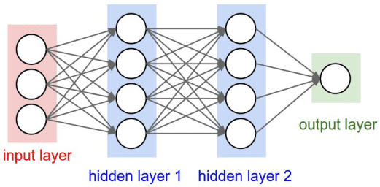

Source: <https://mukulrathi.com/demystifying-deep-learning/feed-forward-neural-network/>

Example: Here is a neural network that process the images and detects their labels as cat or dog.



Source: <https://becominghuman.ai/building-an-image-classifier-using-deep-learning-in-python-totally-from-a-beginners-perspective-be8dbaf22dd8>

## 5.1.3 Historical Background

Deep learning has an interesting history in being closely related to early research into artificial intelligence and computational models of the brain. Its journey could be marked by outstanding moments:

### Early Foundations

* 1943: Warren McCulloch and Walter Pitts proposed the first mathematical model of a neuron.
* 1950s-1980s: Simple neural networks such as the Perceptron preceded this but failed in its limitations, such as not being able to solve non-linear problems.

### The AI Winter

* With limited computing power and no large datasets, theory further depressed interest in neural networks through the late 20th century.

### Resurgence of Deep Learning

* 2006: Interest was sparked by the idea of deep belief networks by Geoffrey Hinton, et al .
* Advances in GPUs, massive datasets (ImageNet), etc. and ideas like ReLU activation and dropout regularization had made deep learning practical and powerful enough.

### Timeline of last decade

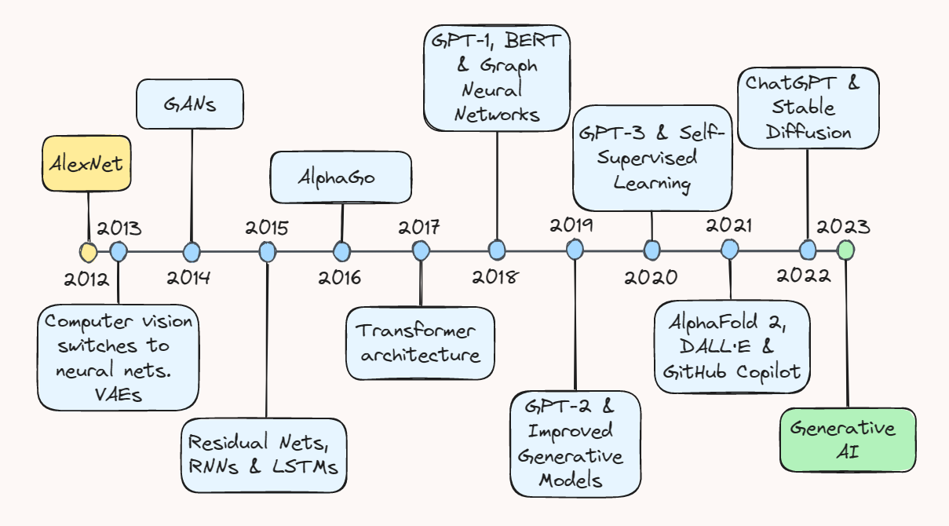

Source: <https://towardsdatascience.com/ten-years-of-ai-in-review-85decdb2a540>

## 5.1.4 Why Deep Learning?

Deep learning has become indispensable for solving some of the most complex and dynamic problems in modern technology.

### Key Advantages

**High Accuracy in Complex Tasks:**

Example: Deep learning achieves state-of-the-art performance in image recognition tasks, outperforming traditional machine learning methods.

**Versatility:**

It crosses paradigms: from natural language processing, where one gets chatbots based on GPT, to healthcare diagnostics, like cancer detection.

**Automation:**

It automatically learns features, minimizing human intervention.

### Real-World Applications

* Image Recognition Applied in photo tagging, facial recognition, and object detection for autonomous driving systems.
* Speech Recognition Enables virtual assistants, such as Alexa and Siri.
* Games: Deep learning reinforcement led to innovations like AlphaGo.
* Natural Language Processing (NLP): Drives translation services, sentiment analysis, and chatbots.

# 5.2 Neurons and Layers

The structure, form, and how a neural network functions can be described as starting off with defining its most basic building blocks: neurons and layers. These pieces work together to allow neural networks to work through data, recognize patterns, and predict potential outcomes. Here we will talk about the foundational elements of neural networks -stems-they include neurons, layers, activation functions, and loss functions, providing necessary groundwork that will help to understand the flow and transformation of data within a network.

## 5.2.1 What's a Neuron?

The smallest computation unit in a neural network is the neuron at its center. This kind of neuron mimics its biological counterparts found in the human brain, which perform the simple yet crucial function of receiving input data, processing using mathematical operations, and producing output. This output forms an input to further neurons in the network, thereby allowing information flow and transformation.

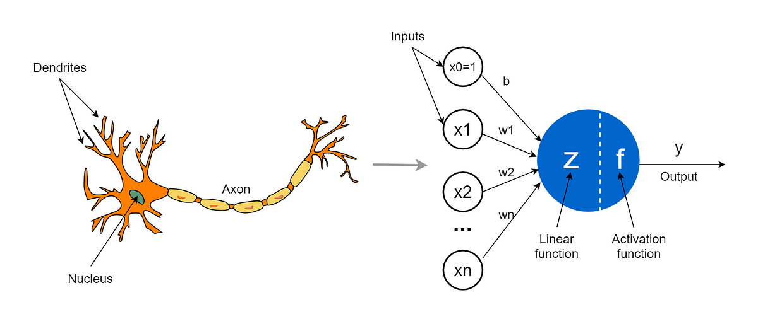

Source: <https://towardsdatascience.com/the-concept-of-artificial-neurons-perceptrons-in-neural-networks-fab22249cbfc>

### Neuron Structure

One neuron can be viewed as a mathematical function that takes inputs, weights their importance, adds a bias term to introduce flexibility, and feeds this result through an activation function that introduces nonlinearity into the model. With this kind of neuron, it can model complex relationships that reside in the data.

**Components of a Neuron**

1. **Inputs** : These are the data points or features fed into the neuron. In a simple dataset, inputs could represent variables such as age, income, or temperature.
2. **Weights** : Each input is multiplied by a corresponding weight. The weight determines the importance or contribution of each input to the final output. During training, the network adjusts these weights to improve predictions.
3. **Bias (b)**: The bias is an additional parameter that helps the neuron fine-tune its output. It shifts the activation function, allowing the network to better fit the data.
4. **Equation**: The computation performed by a single neuron can be summarized mathematically as:

Here, z represents the intermediate result before applying the activation function.

1. **Activation Function**: The result z is passed through an activation function, which transforms it into the neuron's output, introducing the non-linearity necessary for learning complex patterns.

To understand the how neuron works, Imagine a scenario where we want to predict the price of a house based on three features: the number of bedrooms , the square footage , and the distance to the city center . For example, suppose a house has 3 bedrooms , 1500 square feet , and is located 10 miles from the city center . These inputs are processed by a neuron to predict the house price.

Each input is associated with a weight that represents its relative importance in determining the house price. For instance, let the weight for the number of bedrooms be (indicating that each additional bedroom increases the price by $5000), the weight for square footage be (meaning the price increases by $200 for each additional square foot), and the weight for distance from the city center be (suggesting the price decreases by $1000 for each additional mile away from the city). Additionally, a bias (b) is added to fine-tune the prediction, such as , which serves as a baseline adjustment for the price.

The neuron computes the weighted sum of the inputs and the bias using the equation:

Substituting the values, the computation becomes:

The result (z = 305000) is then passed through an activation function, such as the Rectified Linear Unit (ReLU), which outputs the maximum of 0 and z. Since z=305000 is positive, the ReLU function outputs 305000, representing the predicted house price.

## 5.2.2 Layers in a Neural Network

A neural network is essentially a kind of computational system based on the structure and function of the human brain. Neurons are its core building blocks, which are grouped into layers. These layers work in sequence to process data and extract meaningful patterns.

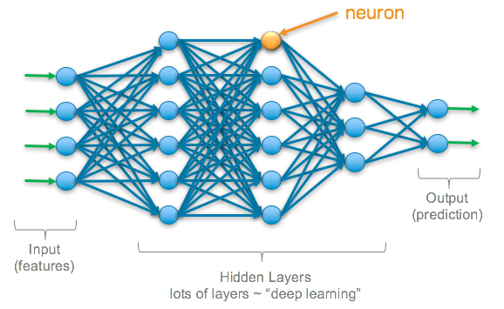

Source: https://srnghn.medium.com/deep-learning-overview-of-neurons-and-activation-functions-1d98286cf1e4

### Input Layer

* The input layer is where the network connects to raw data. It takes input features directly and passes them along to other layers; that's what makes each neuron in the input layer represent a feature of the dataset:
* For image datasets, the input neurons ought to be representing pixel intensities.
* For tabular data, they are to represent single features, like age, or income, or temperature.
* The input layer does not do any computations—it only transmits the unprocessed input to the next layer for processing.

### Hidden Layers

* The hidden layers are the meat of a neural network. These layers process the input data based on mathematical operations intended to uncover patterns, relationships, or hierarchies in the data. Key features of hidden layers are as follows:
* Connections: All the neurons in a hidden layer are connected to both the previous and subsequent layers through weighted edges.
* Weights and Biases: Each connection has a weight that decides its influence, and each neuron has a bias that shifts its activation threshold.
* Activation Functions: This captures non-linear relationships in the data by using specific activation functions on the output from each neuron, such as ReLU (Rectified Linear Unit), sigmoid, or tanh.
* Depth and Abstraction: The more layers that a network contains in hidden layers, the deeper neural networks, which are capable of learning increasingly abstract representations of the data. For example:
  + Early layers may detect edges in an image
  + Intermediate layers may identify shapes or textures.
  + Some of the layers later on can recognize pretty complex objects such as a face or a vehicle.

### Output Layer

* The final output layer is responsible for the network producing what it wants depending on the problem. Depending on what kind of problem, the output layer differs in structure and behavior:
  + Binary Classification: The single neuron in this layer uses sigmoid activation and outputs a probability score corresponding to class membership.
  + Multi-class Classification: Several neurons with the softmax activation function output probabilities for each class.
  + Regression Tasks: One neuron with a linear activation function output a continuous value.
* The output layer makes sure the predictions coming from the network are in line with the problem domain.

### Multilayer Perceptron (MLP)

A Multilayer Perceptron is one of the most basic types of neural networks with the following parts:

* Input Layer: Directly feeds data into the network.
* Hidden Layers: One or more layers where feature transformations and pattern extractions occur.
* Output Layer: Delivers the network’s prediction.

Every connection between neurons employs weights and biases. Activation is used on the output of the neurons for the introduction of non-linearities that enable the network to learn from complex data.

# References:

1. Deep Learning by Ian Goodfellow, Yoshua Bengio, and Aaron Courville
2. Hands-On Machine Learning with Scikit-Learn, Keras, and TensorFlow by Aurélien Géron
3. Neural Networks and Deep Learning by Michael Nielsen
4. Deep Learning with Python by François Chollet
5. Dive into Deep Learning by Aston Zhang, Zachary C. Lipton, Mu Li, and Alexander J. Smola
6. <https://artemoppermann.com/activation-functions-in-deep-learning-sigmoid-tanh-relu/>
7. <https://towardsdatascience.com/activation-functions-neural-networks-1cbd9f8d91d6>
8. <https://taylorandfrancis.com/knowledge/Medicine_and_healthcare/Neurology/Artificial_neural_networks/>
9. <https://en.wikipedia.org/wiki/Neural_net>
10. <https://pytorch.org/vision/0.9/transforms.html>
11. <https://www.ibm.com/think/topics/loss-function>
12. <https://www.ibm.com/topics/recurrent-neural-networks>
13. <https://en.wikipedia.org/wiki/Recurrent_neural_network>
14. <https://taylorandfrancis.com/knowledge/Engineering_and_technology/Artificial_intelligence/Recurrent_neural_networks/>
15. <https://k21academy.com/datascience-blog/machine-learning/recurrent-neural-networks/>
16. <https://arxiv.org/abs/1912.05911>



**Disclaimer: The content is curated from online/offline resources and used for educational purpose only**